11th April 2024

ATP TOUR & YOKOHAMA Tyre Break new ground with global Partnership
ATP and YOKOHAMA are proud to announce a new multi-year global partnership, with the premium Japanese tyre manufacturer becoming the ATP Tour’s first-ever Official Tyre partner.
Renowned for its fearless commitment to performance, YOKOHAMA will leverage the Tour’s year-round platform to bolster its global presence and premium positioning. The brand will activate a portfolio of ATP Tour events, unlocking exclusive experiences for fans at the Rolex Monte-Carlo Masters, Internazionali BNL d’Italia, Cinch Championships (London Queen’s Club), Hamburg European Open and the prestigious Nitto ATP Finals in Turin. Key benefits include on-court and on-site brand visibility, and world-class corporate hospitality.
As Gold Partner, YOKOHAMA will also receive year-round integration on ATP Tour’s social and digital channels, showcasing its performance-driven technologies and innovations.
“We’re incredibly proud to welcome YOKOHAMA as our first Official Tyre partner,” said Daniele Sanò, ATP Chief Business Officer. “Our brands share so many values, including a commitment to high performance and innovation. As a Tour we’re always on the road – a truly authentic platform to tell YOKOHAMA´s brand story.”
Giovanni Ponzoni, CEO Yokohama Europe, said: “We are really delighted to partner with the ATP Tour, a truly global premium platform that shares our commitment to excellence and innovation. This sponsorship provides the perfect stage to expose YOKOHAMA brand and gives us the opportunity to engage our business partners with unique and exclusive experiences”. He added: “Our range of tyres are well-known for incredible performance on different surfaces – much like the players on the ATP Tour. We are extremely proud of becoming the ATP’s Official Tyre Partner, and we aim to leverage this partnership to sustain our brand awareness and continue to expand our footprint across Europe.”
The new partnership kicks off at this week’s Rolex Monte-Carlo Masters.
Media contact: communications@atptour.com

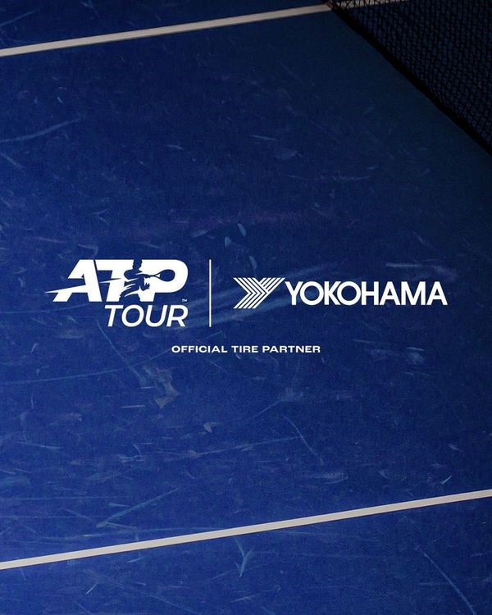

ATP Tour x YOKOHAMA

About The ATP
As the global governing body of men’s professional tennis, the ATP’s mission is to serve tennis. We entertain a billion global fans, showcase the world’s greatest players at the most prestigious tournaments, and inspire the next generation of fans and players. From the United Cup in Australia, to Europe, the Americas and Asia, the stars of the game battle for titles and PIF ATP Rankings points at ATP Masters 1000, 500 and 250 events, and Grand Slams. All roads lead towards the Nitto ATP Finals, the prestigious season finale held in Turin, Italy.
Featuring only the world’s top 8 qualified singles players and doubles teams, the tournament also sees the official crowning of the year-end ATP World No. 1, presented by PIF, the ultimate achievement in tennis. For more information, please visit www.ATPTour.com.
About YOKOHAMA
Established in Japan in 1917, the Yokohama Rubber Company Limited possesses extensive expertise across various industries, encompassing tyres, hose & couplings, conveyor belts, marine products, aircraft fixtures and other industrial products. The company offers a comprehensive product range, including high performance, light truck, passenger car, commercial truck and bus, as well as agricultural machinery, industrial machinery tyres. YOKOHAMA´s consumer tyre business aims to maximize the sales of high-value-added YOKOHAMA tyres, such as the globally renowned ADVAN brand and the GEOLANDAR line tailored for SUVs and pick-up trucks. The company considers engagement in motorsports activities pivotal to its endeavours in developing innovative tyre technologies aimed at fortifying the ADVAN and GEOLANDAR brands.

