22nd April 2024
YOKOHAMA holds groundbreaking ceremony for new passenger car tyre plant in Mexico
YOKOHAMA announces that it recently held a groundbreaking ceremony on 15th April ahead of the start of construction of its new passenger car tyre plant in Mexico. The ceremony was attended by many local government officials and representatives from the local community, including Coahuila Governor Manolo Jiménez Salinas and Saltillo Mayor Jose Maria Fraustro Siller. From Yokohama Rubber, Chairman & CEO Masataka Yamaishi and Member of the Board and Senior Managing Officer & Co-COO Nitin Mantri were joined by Shinichi Takimoto, Chairman and CEO of Yokohama Corporation of North America (YCNA), a YOKOHAMA tyre sales subsidiary, and Jeff Barna, President and CEO of Yokohama Tire Corporation (YTC), a US-based tyre sales subsidiary.
In their opening greetings, Yamaishi and Barna expressed their gratitude in advance for the many efforts to be made in the plant’s construction and mentioned the plant’s importance to localizing YOKOHAMA’s business in the North American market. The new plant will increase YOKOHAMA’s tyre production capacity in North America, enabling the Company to meet an expected increase in future demand in the region with tyres produced locally in the region. The Mexico plant will have an annual production capacity of 5 million tyres. Construction will begin during the second quarter of 2024, with production scheduled to start in the first quarter of 2027. The Company will also consider expanding the plant’s capacity in the future.
The consumer tyre strategy in YOKOHAMA’s new three-year (2024–2026) medium-term management plan, Yokohama Transformation 2026 (YX2026), aims to maximize the sales ratios of high-value-added tyres by expanding sales of YOKOHAMA’s global flagship ADVAN brand, the GEOLANDAR brand of tyres for SUVs and pick-up trucks, winter tyres, and 18-inch and larger tyres. It also will continue its “Product and Regional Strategies” focused on strengthening the development, supply, and sales of tyres that respond to specific trends in each regional market.
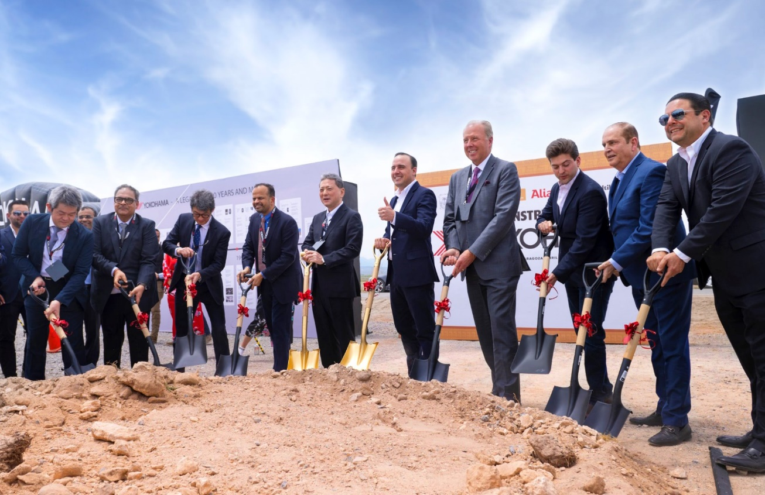
Groundbreaking ceremony attendees: Coahuila Governor Manolo Jiménez Salinas (center right), Yokohama Rubber Chairman & CEO Masataka Yamaishi (center left), YTC President and CEO Jeff Barna (4th from right), YCNA Chairman and CEO Shinichi Takimoto (3rd from left), and Yokohama Rubber Member of the Board and Senior Managing Officer & Co-COO Nitin Mantri (4th from left)

Outline of new plant
Location: Alianza Industrial Park, Saltillo, Coahuila, Mexico
Business: Production of passenger car tyres
Site area: Approx. 610,000 square meters
Annual production capacity: 5 million tyres

