23rd April 2024
YOKOHAMA's GEOLANDAR X-CV and GEOLANDAR A/T G31 tyres coming factory-equipped on Toyota’s new 250 series Land Cruiser
YOKOHAMA announced today that it is supplying its GEOLANDAR X-CV (pattern number: G057) and GEOLANDAR A/T G31 tyres as original equipment (OE) to Toyota Motor Corporation for use on the car manufacturer´s new SUVs , the 250 series Land Cruiser, which launched worldwide in April 2024. The new SUVs are being fitted with two sizes of GEOLANDAR X-CV - 245/70R18 110H and 265/60R20 112H - and two sizes of GEOLANDAR A/T G31 - 245/70R18 110H and 265/65R18 114V.
The GEOLANDAR X-CV represents a new standard in highway terrain tyres, which focus on high-speed performance and manoeuvrability. Meanwhile, the GEOLANDAR A/T G31 is an all-terrain tyre that considers fuel efficiency, silence, and other environmental performance factors along with off-road driving performance. Both tyres achieve a high level of steering stability while reducing rolling resistance and exterior noise. At the same time, they realize a balance in performance ideally suited to the new 250 series Land Cruiser with its ability to perform a diverse range of applications.
The supplied tyres were developed by taking advantage of YOKOHAMA’s proprietary HAICoLab*, an AI-based development framework that aims to foster new discoveries and digital innovation by merging human inspiration and creativity with AI’s enormous data-processing capability. The innovative technologies applied in development of the tyres are based on new knowledge obtained by collecting actual data and virtual data generated by simulations and then using AI’s predict, analyse and search functions.
* An acronym for “Humans and AI ColLaborate” for digital innovation
Under YOKOHAMA’s three-year (2024–2026) medium-term management plan, Yokohama Transformation 2026 (YX2026), the consumer tyre business aims to maximize the sales ratios of high-value-added tyres. One of the key initiatives under this strategy is promoting the global flagship ADVAN brand tyres and the GEOLANDAR brand tyres for SUVs and pick-up trucks as original equipment for new cars.
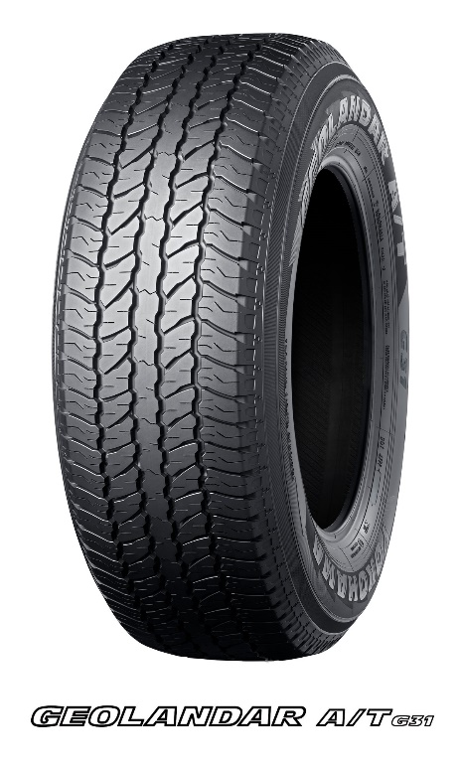
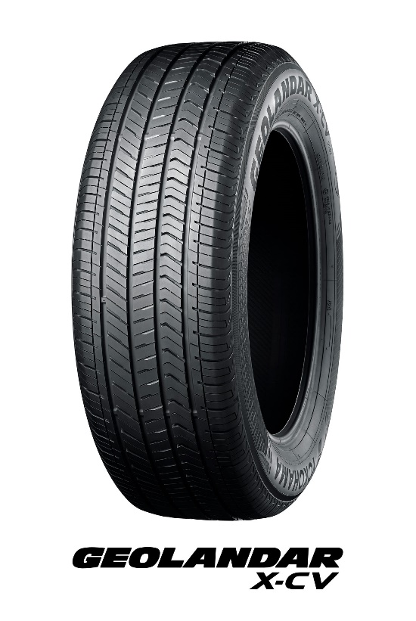
*The tyre size in the photo is 265/65R18 114V

* The tyre shown in the photo differs in size from those installed on the new 250 series Land Cruiser.

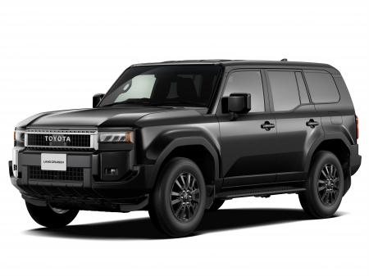
All-new 250 series Land Cruiser *The above photo is used with the permission of Toyota Motor Corporation. Reprint or other usage of this image is strictly prohibited.

HAICoLab conceptual diagram

