16th July 2021

YOKOHAMA supported team wins Round 6 of the Nürburgring Endurance Series

YOKOHAMA is pleased to announce that Walkenhorst Motorsport, a BMW customer racing team that uses YOKOHAMA’s ADVAN global flagship brand tyres, was the overall winner of the 44th RCM DMV Grenzlandrennen, the sixth round of this year’s Nürburgring Endurance Series (NLS), held on July 11. The winning BMW M6 GT3 was outfitted with “ADVAN A005” tyres for use in dry conditions.

Competing in the series’ highest class, SP9 Pro, the race winning Walkenhorst Motorsport BMW M6 GT3 was driven by Christian Krognes, David Pittard, and Ben Tuck. In the morning qualifying race, Christian Krognes set an NLS lap record of 7:51:807 minutes to secure the pole position for the afternoon race. The team’s three drivers then pushed the pace from their start in pole position all the way to the finish line. This gave the Walkenhorst Motorsport team their first win of the 2021 NLS season. Having entered into a partnership agreement with Walkenhorst Motorsport, YOKOHAMA provided tyres for all three of the team’s BMW M6 GT3 cars racing in the top SP9 Pro class as well as its BMW M4 GT4 competing in the SP10 class.

The world's largest grassroots racing series, the NLS is run on the Nürburgring Nordschleife (“North loop” track), which is said to be the world's most demanding course, and the Grand Prix track. Around 170 vehicles are participating in the nine NLS races scheduled to be held between March* and October this year.
* This year’s opening race in March was cancelled owing to snow.

The consumer tyre business in YOKOHAMA’s new three-year (2021–2023) medium-term management plan, Yokohama Transformation 2023 (YX2023), aims to maximize the sales ratios of high-value-added YOKOHAMA tyres, namely the global flagship ADVAN brand, the GEOLANDAR brand of tyres for SUVs and pickup trucks, and various winter tyres. YX2023 positions participation in motorsports activities as crucial to the company’s effort to develop new tire technologies that will further strengthen the ADVAN and GEOLANDAR brands. YOKOHAMA therefore is again participating in a wide variety of motorsports events in Japan and around the globe, from top-category to grassroots events.

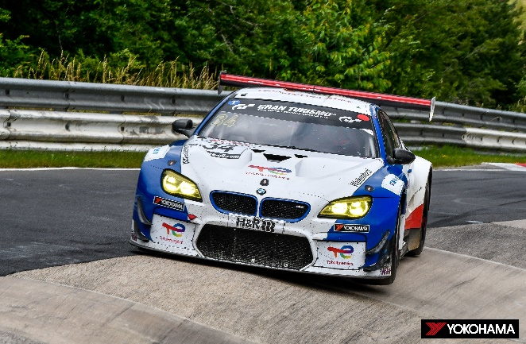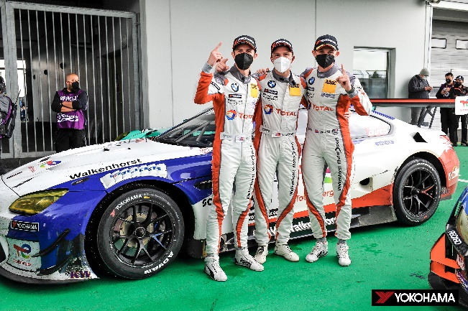
The NLS Round 6 winning BMW M6 GT3 The winning team drivers - Ben Tuck,
Christian Krognes, and David Pittard
(from left to right)

