7th May 2021

YOKOHAMA tyre–equipped machine wins class at off-road endurance race in Mexico

YOKOHAMA is pleased to announce that a machine running on its off-road racing tyres achieved victory in the Pro UTV NA* class of the 34th SCORE San Felipe 250, an off-road race held in San Felipe, Baja California, Mexico during 14th - 18th April.
*Normally Aspirated UTVs

The SCORE San Felipe 250 kicked off the four-race SCORE World Desert Championship, which culminates with the Baja 1000, widely regarded as one of the world’s toughest off-road races. The SCORE San Felipe 250 was run over a more than 280-mile (450km) desert course laden with sharp stones, bumps and crevices.

Kristen Matlock was the winner in the Pro UTV NA class. This year’s SCORE San Felipe 250 included eight machines running on YOKOHAMA supplied tyres, including its GEOLANDAR tyres for SUVs and pickup trucks. Six of those machines successfully completed the race. The YOKOHAMA tyres supported the competing drivers by demonstrating their strong durability and excellent manoeuvrability over rugged terrain.

The consumer tyre business in YOKOHAMA’s new three-year (2021–2023) medium-term management plan, Yokohama Transformation 2023 (YX2023), aims to maximize the sales ratios of high-value-added YOKOHAMA tyres, namely the global flagship ADVAN brand, the GEOLANDAR brand of tyres for SUVs and pickup trucks, and various winter tyres. YX2023 positions participation in motorsports activities as crucial to the company’s effort to develop new tyre technologies that will further strengthen the ADVAN and GEOLANDAR brands. YOKOHAMA therefore is again participating in a wide variety of motorsports events in Japan and around the globe, from top-category to grassroots events.

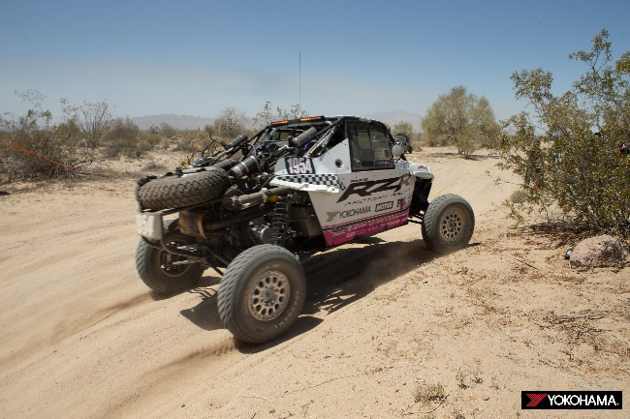
The Pro UTV NA class winning UTV driven by Kristen Matlock

